**Introduction to Databases**

Problem Statement: There can be multiple customers, who can place multiple orders on the site. Now a sales person can handle these orders will distribute into multiple sales persons (One order will be assign to one salesperson only). So a sales person can have multiple orders of multiple customers.

Q.1 Create Database

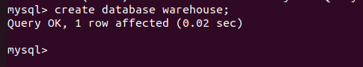

Q.2 Design Schema

Customer table- c_id(PK) , phone_no , adress , email_id

Salesperson table- s_id(PK) , phone_no , email_id

Order table- o_id(PK) , c_id(FK) ,s_id(FK)

Q.3 Create tables







Q.4 Insert sample data







Q.5 Find the sales person have multiple orders.

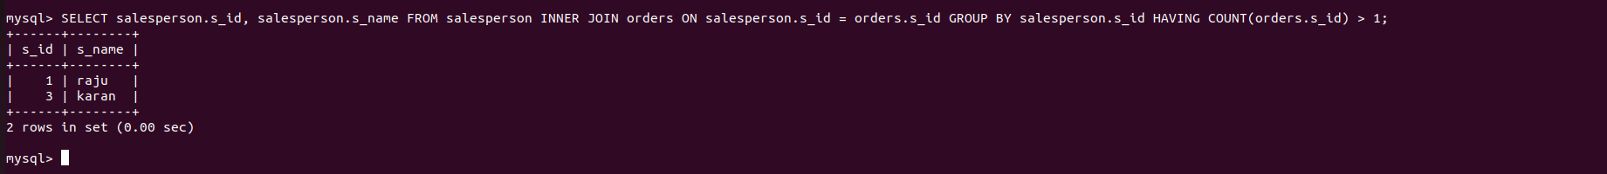

Q.6 Find the all sales person details along with order details

Note-we have done left join union right join instead of full outer join as full outer join is not available in mysql.

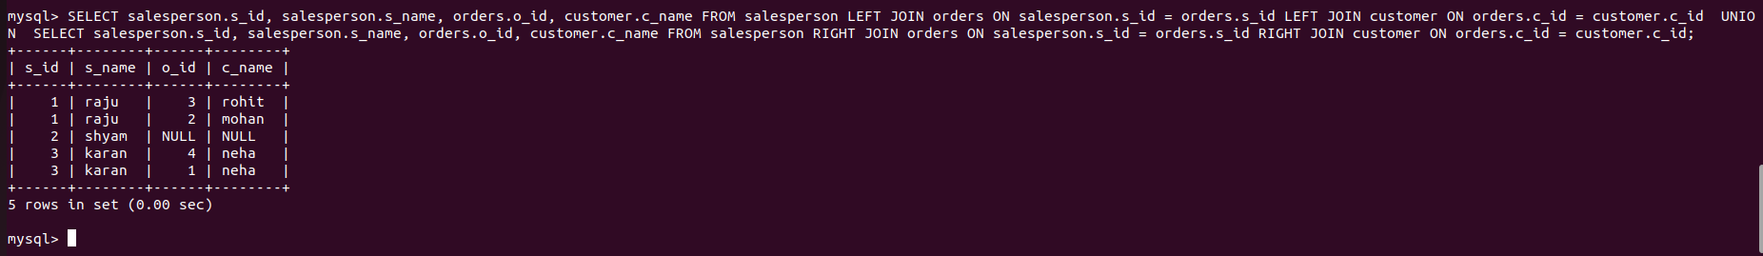

Q.7 Create index

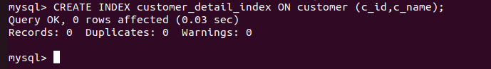

Q.8 How to show index on a table



Q.9 Find the order number, sale person name, along with the customer to whom that order belongs to

